The Smythe Hall Management Committee who meet two or three times a year to keep the hall running are in need of a volunteer secretary to take meeting minutes. Could this be you? Please come along on the 8th December to find out more , or contact us via the Smythe Hall page on the village website.

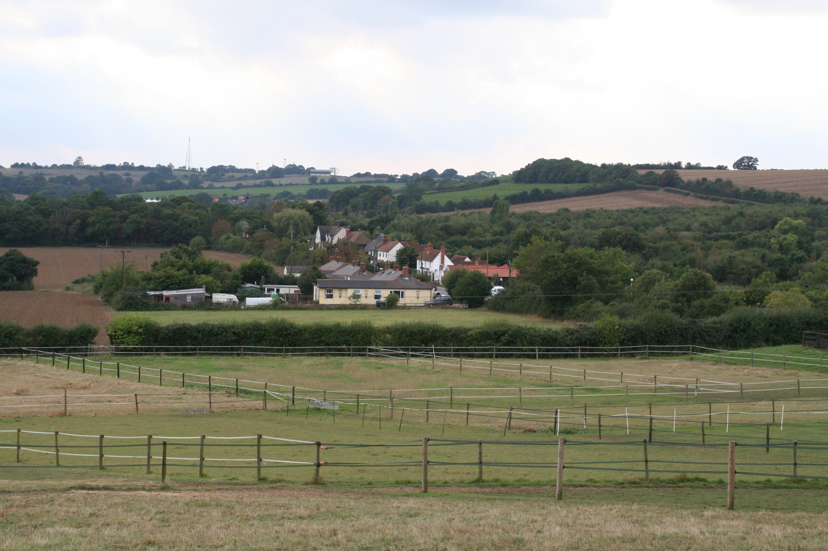

Did you know Stow Maries has a new village web site?
For Village Events and Parish Council news etc.
Take a look at www.stowmaries-village.org.uk/

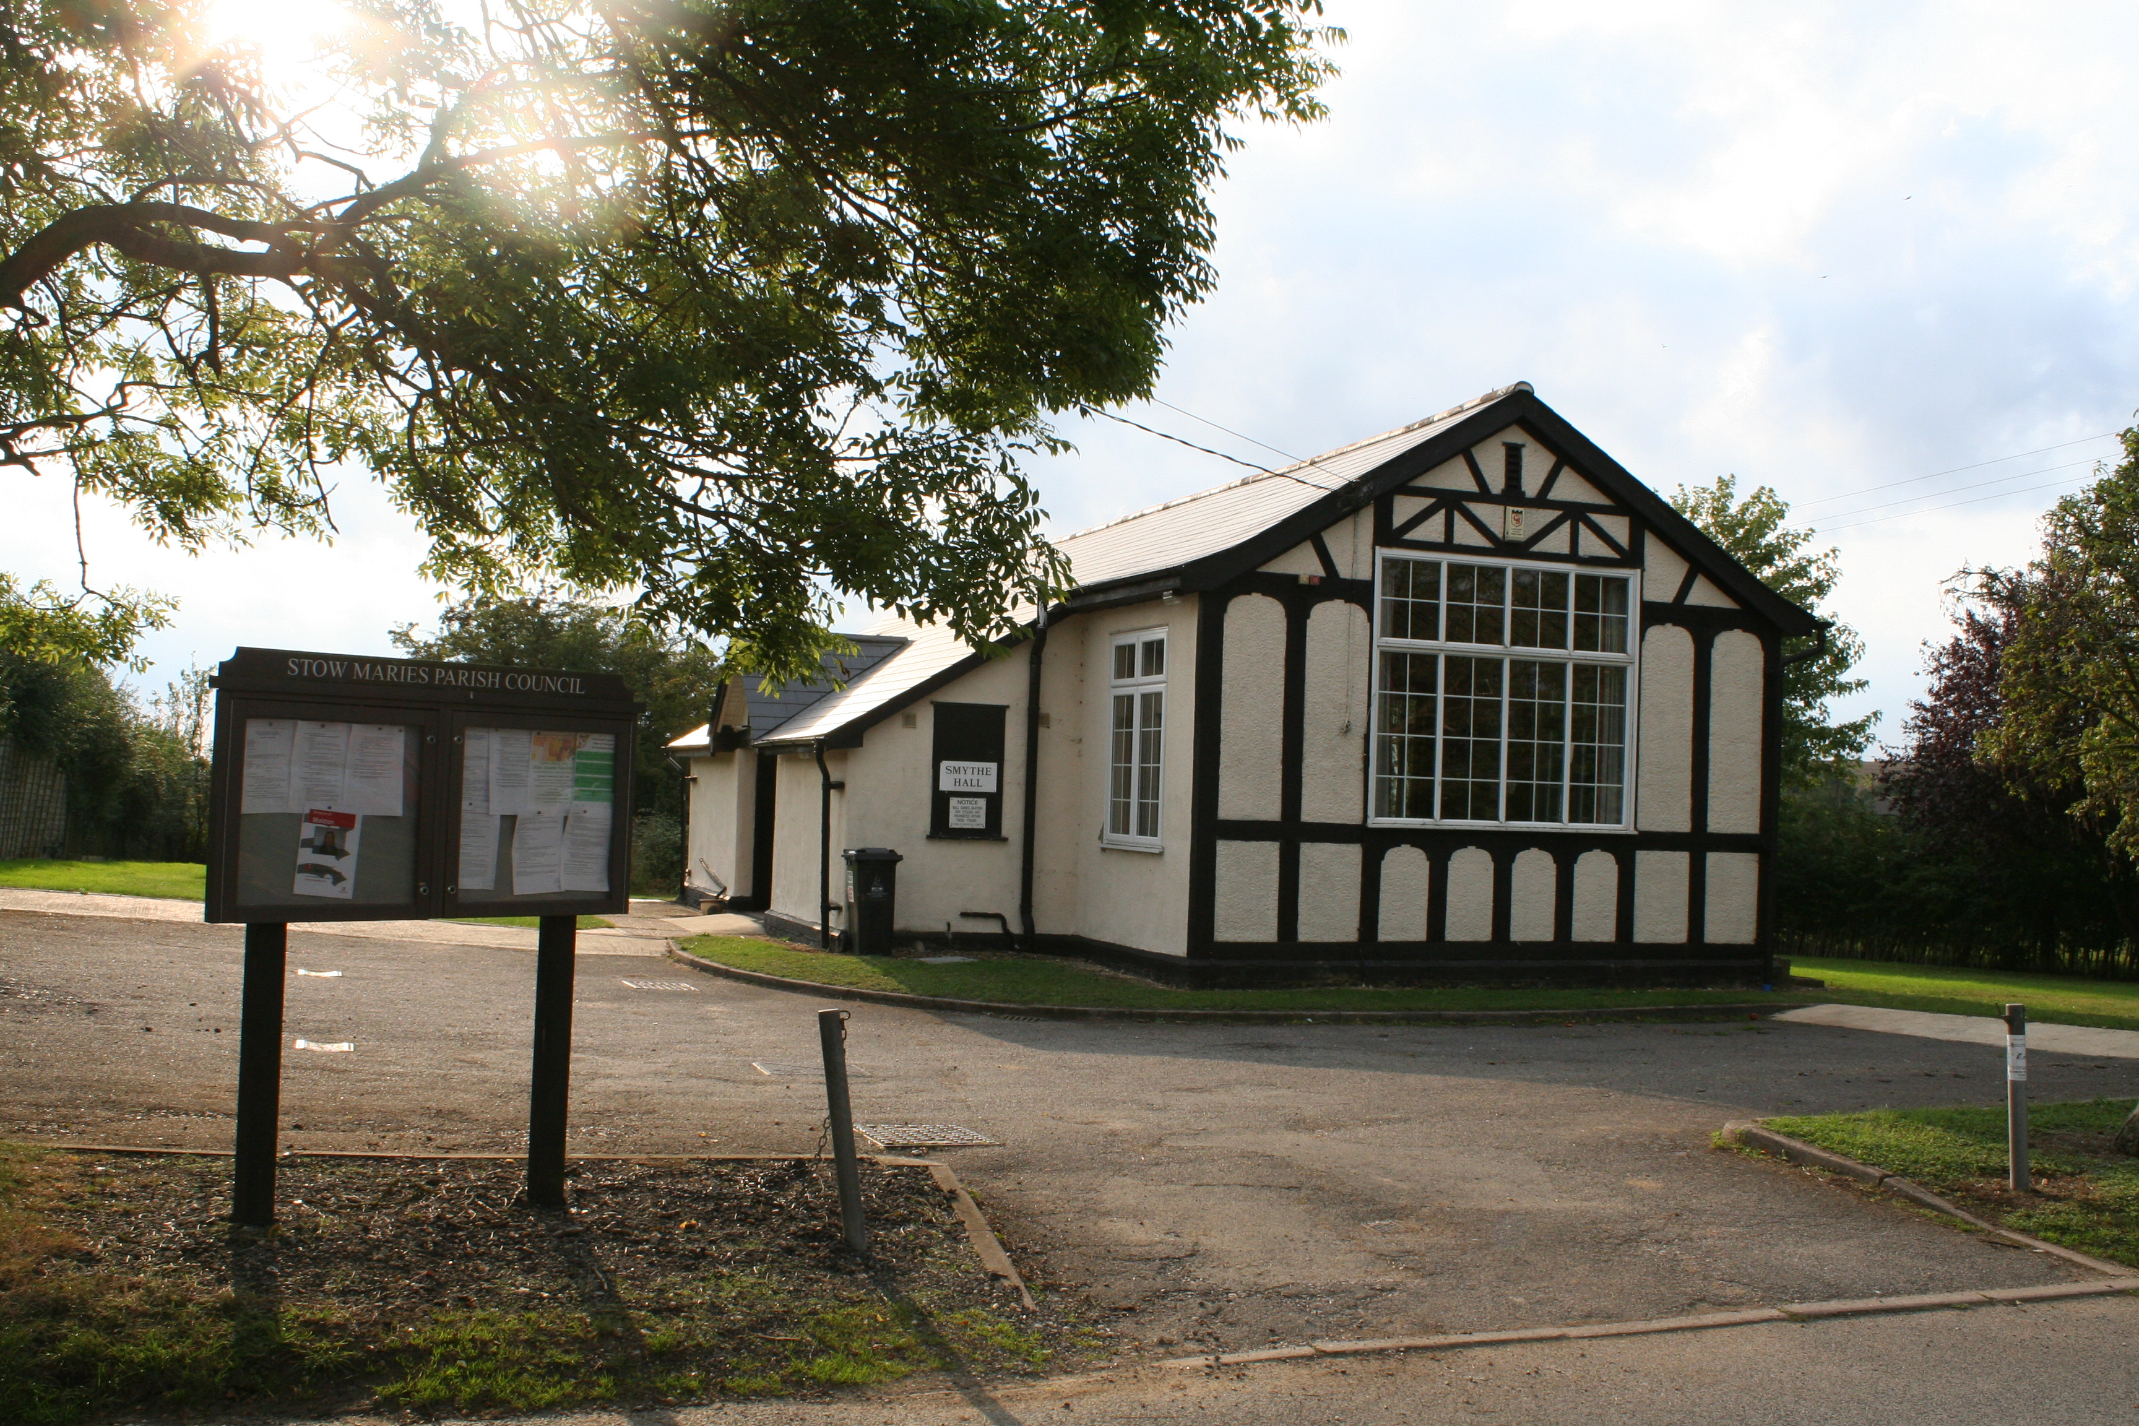
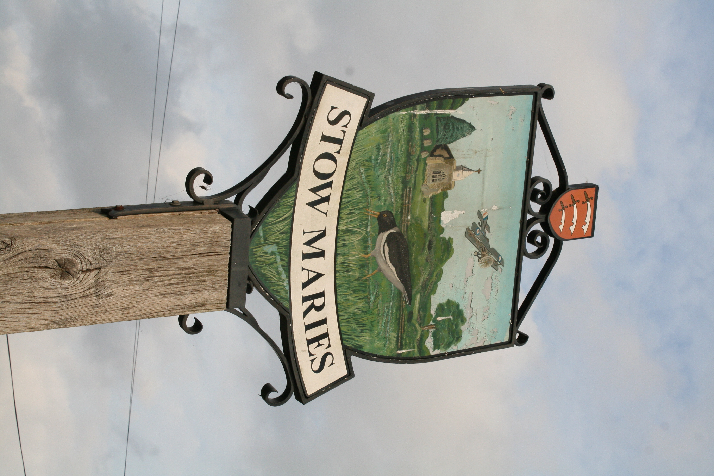

STOW MARIES
IT’S ABOUT TIME WE HAD ANOTHER
VILLAGE SOCIAL EVENT!!!
So we’re going to hold one in the
Smythe Hall, Church Lane at:
7pm on Wednesday 8th December
The aim of this get-together is to say hello and resurrect and re-energise the village Fund Raising Group by getting ideas from YOU – this WILL NOT commit you to joining the Fund Raising Group! (but you would be made very welcome if you did)
Whether you are a new or long-standing resident, we hope you share our wish to help this village be a great place to live – so please come along.
As it’s a social event, we’ll be providing light refreshments (tea, coffee, cakes, biscuits, etc.).
P.T.O
Note: All proceeds from events organised by the Fund Raising Group go towards the upkeep of the Smythe Hall and St Mary & St Margaret’s Church.

Note: All proceeds from events organised by the Fund Raising Group go towards the upkeep of the Smythe Hall and St Mary & St Margaret’s Church.

and there will be prize draw based on the number show

