An evening of Family Fun at the
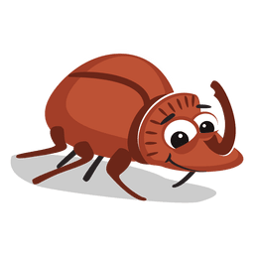
STOW MARIES’
BEETLE DRIVE

At 7pm on Friday 22nd April 2022
In The Smythe Hall (CM3 6SL)

Tickets cost £10 per person (£5 for under 12s)
and must be purchased in advance by
contacting 01621 828879 (or 828536)

A Fish & Chip Supper* will be provided
but please bring your own drinks
[* an alternative will be available on request]

Additional fun competition during the evening

Proceeds in aid of The Smythe Hall and the Church of St Mary & St Margaret

