
MALDON DIVISION MONTHLY UPDATE – COUNCILLOR JANE FLEMING

FUNDING FOR SMALL BUSINESSES LOOKING TO EMPLOY PEOPLE WITH LEARNING DISABILITIES AND AUTISM
Essex County Council has opened applications for the third round of its learning disabilities and autism business grants.
A total of £195,000 is available for Small and Medium Sized businesses, with £150,000 of it coming from the county council. The pot has been further boosted by Chelmsford City Council and Epping Forest District Council via the Government’s UK Shared Prosperity Fund.
Grants of up to £25,000 are available to successful applicants. The aim is to break down barriers and create meaningful jobs for people with additional needs.
The funding can be used to support a range of business needs. This includes salaries, business start-up costs or equipment and training.
The scheme has run twice before. It won the 'Innovation of the Year' award 2023 from The British Association for Supported Employment.
This funding opportunity is for a business that:
- has a new, creative innovative business proposal
- has a proposal that is both viable and sustainable
- wants to open or expand and employ adults with learning disabilities and/or autism
To find out more information and request an application pack email BusinessGrants@essex.gov.uk. The closing date for applications is 12 August 2025.

THE AMBITIOUS ESSEX GROWTH HUB
Essex entrepreneurs will continue to benefit from specialist business support, thanks to the relaunch of the Ambitious Essex Growth Hub.
Through the Ambitious Essex Growth Hub, new provider Smarter Society will offer training, mentoring and support programmes to help businesses to grow and develop.
Growth Hubs are established business support services funded by the Government. They play an essential role in growing the local economy and help businesses to thrive.
Previously the BEST Growth Hub, Essex’s service launched in 2015. From April 2024 to April 2025, it assisted with 321 business enquiries.
The Hub helps business owners through free signposting, problem diagnosis and specialist guidance.
The Ambitious Essex Growth Hub will offer:
- information, navigation and signposting via a coordinated multi-channel service
- structured support, including a diagnostic assessment of business needs and advice and guidance
- expert-led mentoring
- a series of hybrid workshops focused on key business topics such as growth, branding and AI
New additions to the Ambitious Essex Growth Hub offer will also include:
- specialised support for women in business through a dedicated mentoring service from experienced female entrepreneurs
- a Digitech competition offering five winners expert marketing support, business coaching and increased publicity
Find out how to access support through the Ambitious Essex Growth Hub at: www.ambitiousessex.co.uk.

PRIORITY ONE PROGRAMME – ADDITIONAL INVESTMENT IN ESSEX HIGHWAYS
£25 million worth of improvements have been made in addition to normal highways maintenance.
The single largest investment in Essex Highways has resulted in thousands of fixes to overgrown vegetation, tired signage, damaged drains and broken bollards.
The £25 million Priority One programme was launched by Essex County Council in August 2024 to target issues specifically reported by residents in every district, city and borough.
The investment is in addition to the council’s annual highways maintenance budget, enabling extra crews and resources to be committed.
The Priority One programme has resulted in:
- 824 drainage clearances
- 582 vegetation clearances
- 446 signage and bollard repairs
- 30 drainage repairs
128 roads have also been resurfaced as a result of the Priority One programme.
Further investment into Essex’s roads will continue in 2025/26 on top of the annual maintenance budget.
Visit www.essexhighways.org/priority-one for more information about the Priority One programme.

FREE COURSES WITH THE ESSEX YEAR OF OPPORTUNITY
New directory offers HSBC financial education, an Aerospace Careers Programme and more.
Essex residents of all ages can now access opportunities to build essential skills and improve their career prospects.
A new directory by the Essex Year of Opportunity promotes more than 30 courses, certificates, skills hubs and resources to open the door into work, education and career advancement for millions of residents.
This includes:
- Aerospace Careers Programme
- Engineering a Career Course
- Functional Skills – Pathways to Success
- Greater Essex Careers Hub
- HSBC UK Financial Education Certificate
- My Future Programme – introducing primary school children to the world of work
- Post-16 GCSE Maths Resit
- Step into STEAM (Science Technology Engineering Arts and Maths)
- TechSheCan – improving the journey of young women into tech careers
- University of Essex resources for students and teachers
Essex Year of Opportunity has been launched by Essex County Council following the hugely successful Essex Year of Reading and Essex Year of Numbers.
The campaign aims to remove barriers into work, education and career advancement by opening doors to essential skills.
The directory for the Essex Year of Opportunity can be viewed at www.essexyearofopportunity.co.uk/project-directory

ADULT SOCIAL CARE TRANSPORT SURVEY
We’re committed to improving transport being used to access day centres and we need your feedback.
This survey is for adults who use day centres, their families and carers, and the staff who support them. We want to know how the transport service impacts you, what you think about its safety, length of journey and overall quality. Complete the Adult Social Care transport survey by 1 August 2025 and help us improve access to day centres across the county.

FREE WEIGHT LOSS PROGRAMMES WITH THE ESSEX WELLBEING SURVEY
Ahead of Diabetes Week on 9 June, we want to raise awareness of the link between excess weight and the development of type 2 diabetes.
Losing weight can help manage and even reverse type 2 diabetes. It can also improve the effectiveness of insulin in both types of diabetes. Essex Wellbeing Service offers free weight loss programmes tailored to your needs either online, via telephone or face-to-face.

KINDER ESSEX
Loneliness Awareness Week starts on Monday 9 June, and it’s the perfect time to come together and make a difference. Through the Kinder Essex programme, hundreds of community, charity, and voluntary groups across the county are joining forces. They’re working to tackle loneliness and social isolation, through acts of kindness and support.
Kinder Essex have dedicated Kindness Coaches to help connect people with friends, neighbours and strangers to overcome feelings of isolation. If you are feeling lonely, you can get in touch with Kindness Coaches via email, or by calling 0300 303 9988.

SCRAP IT – THE STOP FLY TIPPING CAMPAIGN
Over the past few months, we've been working with nine local authorities in Essex to tackle fly tipping across the county. The campaign included educational resources, increased patrols, and local councils and organisations working together.
Last week, we met with the councils involved to see how the project has gone. Some of the highlights were:
- reduced fly tipping in hotspot areas
- 29 fines issued
- 545 vehicle stops
- 108 ongoing investigations
Hopefully you’ve seen the SCRAP campaign messages on buses, bus stops, petrol pumps, and more, in your local area. To learn more or report a fly tipping incident, visit our website.

ESSEX ENERGY SWITCH
Tired of high energy bills? Join the Essex Energy Switch to save more by teaming up with other Essex residents!
Interested? Registration is free with no obligation. Enjoy 100% renewable electricity if you do decide to switch.
Why join?
• it's quick and easy to register with a recent energy bill
• suppliers compete in an auction to offer the lowest tariffs
• our scheme partner, IChoosr, handles the entire switching process
• join thousands of households already saving on their energy

Don’t miss out on this hassle-free opportunity to lower your energy costs. Register by Monday 23 June to take control of your energy bills.

VOLUNTEER WITH ESSEX LIBRARY SERVICE
Looking for a fun and meaningful way to spend your summer? Essex Library Service are looking for enthusiastic volunteers aged 14-years or older to take part in the Summer Reading Challenge.
Volunteers will talk to children about the books they’re reading, share reading rewards and help inspire a lifelong love of reading. Volunteering is a great opportunity to support your local community and looks great on your CV. Find out more and apply for the Summer Reading Challenge.
REPORT ISSUES ON THE ROADS
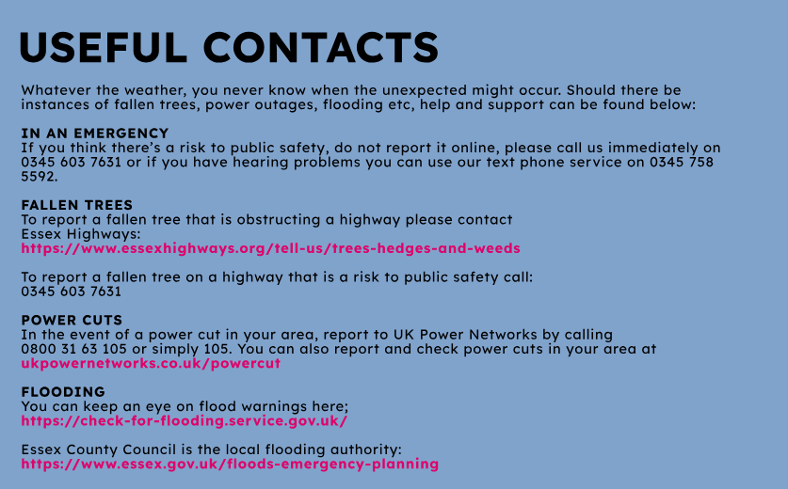
If you come across an issue on the roads, please report it on the Essex Highways website, or call the appropriate number in the image above.

Cllr Jane Fleming
Member for the Maldon Division
(Maldon Town and Parishes of Woodham Walter, Woodham Mortimer with Hazeleigh, Purleigh including Cock Clarks, Cold Norton, Stow Maries, North Fambridge)
cllr.jane.fleming@essex.gov.uk

