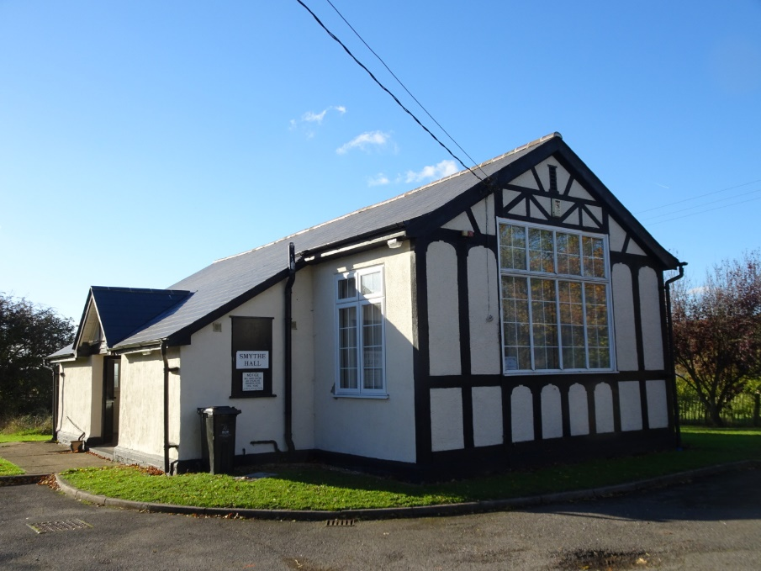

SMYTHE HALL

HEALTH AND SAFETY POLICY

January 2026

Health and Safety Policy

General Statement of Policy

Smythe Hall Management Committee has drawn up this policy to set out procedures and areas of responsibility to ensure the hall, and any equipment is safe for the purposes of Management Committee members, hirers and visitors.

It is the intention of Smythe Hall Management Committee to comply with all relevant Health and Safety legislation and to act positively where it can reasonable do so to prevent injury, ill health or any danger arising from its activities and operations.

The Committee will encourage its members, hirers and other visitors to recognise that there is a duty on them to comply with all safety requirements set out in the Hiring Agreement, with safety notices on the premises and to accept responsibility to do everything they can to prevent injury to themselves or others.

Organisation of Health and Safety

To mitigate risk the Committee will

- Annually review this Health and Safety Policy and cascade to all volunteers
- Carry out a full Risk Assessment every year or sooner if deemed necessary
- Discuss and report on Health and Safety at every Committee meeting
- Carry out a Fire Risk Assessment every year or sooner if deemed necessary
- Arrange Periodic inspection of electrical wiring every 5 years
- Visually inspect all electrical equipment on a regular basis
- Arrange a Portable Appliance test every two years for electrical equipment not double insulated
- Complete a Risk Assessment for all activities held by the Smythe Hall Management Committee or sub-committee Stow Maries Fund Raising Group, including a note that any necessary training for volunteers has been completed
- Display this Health and Safety Policy in the hall and on the Hall website
- Ensure that hazardous substances/materials are not used in Smythe Hall including
  - Naked flames including candles and fireworks
  - Flammable liquids
- Ensure that smoking is forbidden in the Hall
- Ensure that emergency exits and routes to them are kept clear/unlocked at all times
- Ensure that Fire Equipment is kept clear and maintained/checked annually by an approved company
- Organise Hall Insurance annually – a copy of the certificate to be displayed inside the Hall
  - All committee members are covered similarly, regardless of age. There is potential for a claim if an accident is the result of a fault in the hall or grounds. It is the responsibility of all to take the utmost care when undertaking voluntary work.
- Clean the hall on a regular basis
- Request chairs are stacked at 8 high or less and chairs & tables do not block access to the kitchen hatch and fire escape
The User

It is the duty of all hirers, users and visitors to take care of themselves and others who may be affected by their activities and to co-operate with the Committee in keeping the premises, including the grounds, safe and fit for purpose.

All hirers will be expected to read the whole of the hiring agreement and should sign the hiring form as evidence that they agree to the hiring conditions.

The hirer shall not use naked flames within the hall or Bar-b-ques and fireworks in the hall grounds due to the wooden construction of the building.

The Hall is a public space and therefore is legally required to be smoke free.

Housekeeping - Every user has a responsibility to ensure the Hall is left clean and tidy. Party booking hirers are to take away all rubbish at the end of their hire.

The grounds outside and frontage of the Hall are to be left clean and tidy.

Should anyone using the Hall discover a fault, damage or other situation which might cause injury and which cannot be rectified they should inform the Bookings Clerk as soon as possible so the problem can be dealt with, who will inform the Committee.

Where equipment is damaged or faulty the Committee will place a notice on it.

Noise - As the Hall is situated in a residential area, users should be considerate and keep noise levels to a minimum. Playing any form of music, whether live or recorded, must be kept to an acceptable level and must cease at 11.00pm.

Users must vacate the hall by 11.00pm being considerate to neighbours when leaving.

Parking – Parking in the grounds of the Hall is limited and at the users’ risk. Driveways are not to be obstructed or the road blocked. Cars may be parked on the grass in front of the Hall’s main entrance, which has reinforcement mesh.

Accident Reporting Procedure – The following must be reported to the Bookings Clerk and an Accident Report Form completed
- A dangerous occurrence
- Any injury that results in a member of the public having to be taken to hospital

Safeguarding - It is the responsibility of hirers to ensure that adequate safeguards are in place to protect the well-being of children and vulnerable adults.

In case of fire – the hirer is deemed the ‘Responsible Person’ and is designated the person in charge of the Hall during the period of hire.

The Responsible Person is strongly advised to record the name of each person attending the event.

In the event of a fire, the Responsible Person shall

- Instruct all persons to leave the building using the nearest available Emergency Exit and to muster together as soon as possible at the roadside verge. A roll call should be taken
- No matter how small the fire. THE FIRE BRIGADE MUST BE CALLED ON 999, giving the address: Smythe Hall, Church Lane, Stow Maries, Essex. CM3 6SL
- On arrival of the Fire Brigade, the Responsible Person shall inform the Officer that a roll call has been taken and all person are safe/there are missing persons
- Attempts to extinguish the outbreak of the fire with the firefighting equipment within the hall should only be attempted if it is considered safe to do so
- As soon as the previous steps has been carried out the Responsible Person shall inform Smythe Hall Management Committee on either 07930361698 or 07788 135914

Electrical Safety

The following must be adhered to

- Electrical appliances must not be left unsupervised when in operation
- Plug sockets must not be overloaded
- Should hirers want to bring electrical appliances onto the premises they must make the Bookings Clerk aware of this in advance. The hirer is responsible for ensuring appliances meet safety standards
- Trailing cables are a trip hazard and should be taped down with appropriate high visibility tape
- Hirers have a responsibility to ensure when leaving the hall all electrical appliances are turned off including the hall heating and the kitchen water heater.

Contractors

The Management Committee will check with contractors (including self-employed persons) before they start work that

- They are competent to carry out the work (they have appropriate qualifications, references, experience)
- Have adequate public liability insurance cover
- Have their own health and safety policy for their staff
- Are aware of any hazards which might arise
- Any alterations or additions must conform to current regulations

